**Monitoring Windows OS with Prometheus**

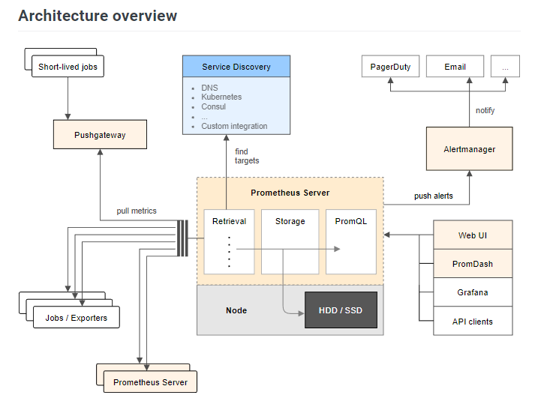

* **We will need to install Prometheus on a machine to store and analyze the metrics collected by the Windows Exporter.**
* **The Windows Exporter is a separate tool that runs on the Windows machine and collects system-level metrics, such as CPU usage and memory usage, which are exposed in a format that Prometheus can scrape**. Prometheus then stores these metrics and provides a user interface for visualizing and analyzing them.

Therefore, to monitor a Windows machine with Prometheus, you will need to:

1. Install Prometheus on a machine
2. Install the Windows Exporter on the Windows machine you want to monitor
3. Configure Prometheus to scrape metrics from the Windows Exporter running on the Windows machine

Firstly I will start with installing Prometheus with Docker:

* Create a new directory for the Prometheus configuration and data files.
* Create a file called **prometheus.yml** in the new directory, and add the following contents.
* This configuration file specifies that Prometheus should scrape data from itself (running on **localhost:9090**) every 15 seconds.
* Start a new Prometheus container using the official Prometheus Docker image:
* docker run -d --name prometheus -p 9090:9090 -v C:\Users\stani\Desktop\prometheus-data:/prometheus-data prom/prometheus --config.file=/prometheus-data/prometheus.yml.
* This command starts a new Prometheus container in detached mode (**-d**) with the name **prometheus**, maps port 9090 on the host to port 9090 in the container (**-p 9090:9090**), mounts the **prometheus-data** directory on the host to **/prometheus-data** in the container (**-v** C:\Users\stani\Desktop\prometheus-data:/prometheus-data), and specifies the path to the Prometheus configuration file using the **--config.file** option.
* We can access the Prometheus web interface by opening a web browser and navigating to http://localhost:9090. From here, you can view metrics, set up alerting rules, and perform other monitoring tasks.

After installing Prometheus we will need the Windows Exporter:

* The URL, that is used is the same, specified in the exercise: <https://github.com/prometheus-community/windows_exporter/releases/tag/v0.22.0>
* Downloading the **windows_exporter-*-amd64.msi.**
* After that we should install it:
* Navigating to the directory Downloads/ in the terminal, after that executing:

msiexec /i .\windows_exporter-0.16.0-amd64.msi

* To verify whether Windows Exporter is working, open a web browser and visit <http://localhost:9182/metrics>. If you see the following output, then Windows Exporter is working.

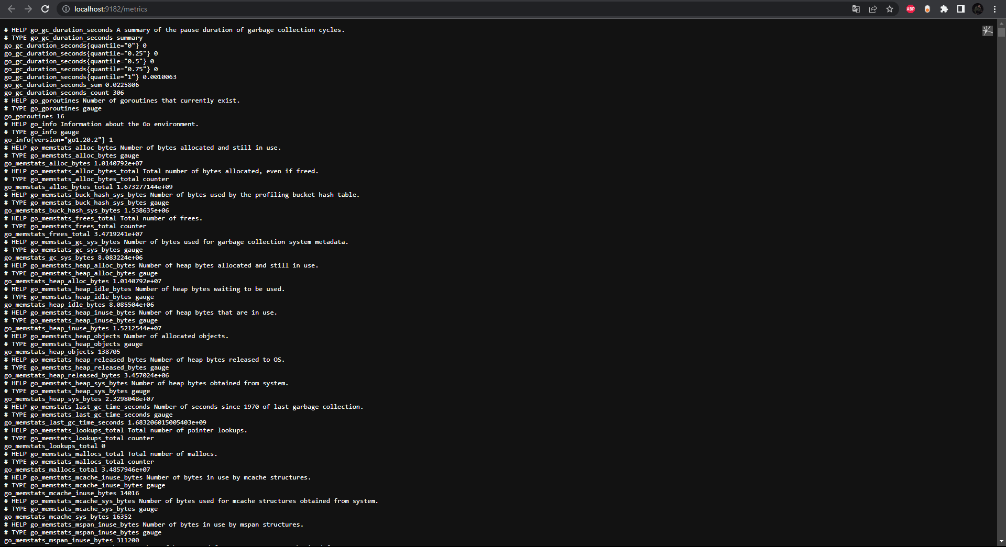

* After installing the Windows Exporter and Prometheus, we should should be able to add Windows Exporter to Prometheus.
* We need our IPv4 Address: Mine is: 192.168.56.1
* Now we need to open the Prometheus configuration file and add the job, also specify the target IP address of our Windows computer:

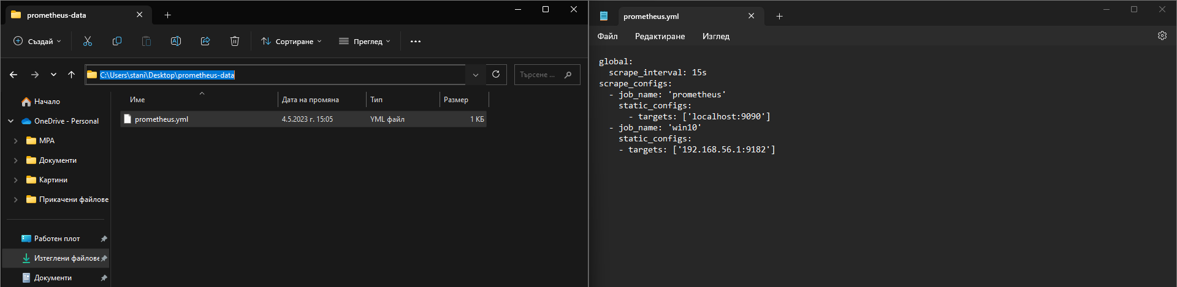

* After that we can navigate to localhost:9090/targets:

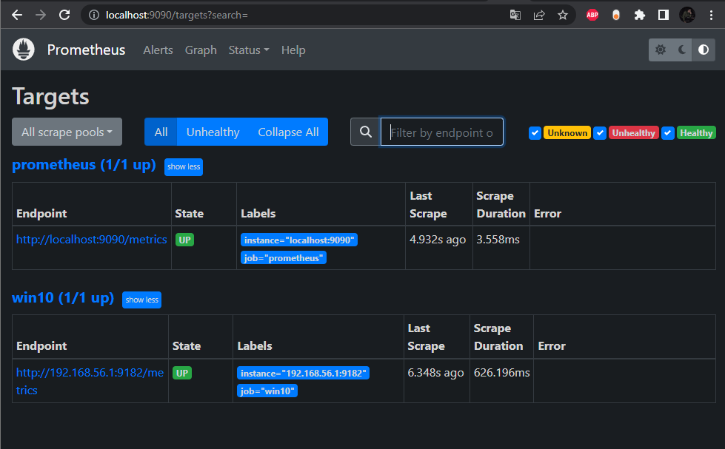

* In order to monitor Windows with Prometheus we can visit localhost:9090/graph
* Also monitor the download speed of your Windows computer, run the expression **rate(windows_net_bytes_received_total[1m])**.
* You should see a graph of the download speed of your Windows computer, as shown in the screenshot below.

